**Green Fund HACK-A-THON**

**Table of contents:**

* Introduction
* Setup
* How To Use the Dashboard
* Screenshots to show the functionality of the Dashboard

**Acknowledgments:**

We want to express our gratitude to Professor Dr. Somya Mohanty and Will Queen for providing their support in clarifying our doubts. Our special thanks to UNCG Green Fund for funding this Hackathon.

**1.Introduction :**

An interactive dashboard has been developed in this project to summarize high-frequency energy consumption data in 81 electricity meters on UNCG’s campus. These meters represent the power utilization of various buildings across UNCG and help the university understand the requirements and usage of energy consumption and efficiency.

Prior work in the project has achieved scripts to clean, summarize, and predict energy use using statistical models with data on meter readings, local weather conditions, and classroom occupancy. These scripts are written in Python and extract data from various API sources. The available cleaned data is available at: <https://github.com/UNCG-DAISY/Green_Hackathon-Fall2020/tree/main/data/Analysis> .

**2. Setup:**

To get started, you will need to either be running editors like Pycharm Professional editor or Visual Studio editor.

**2.1 Installing Basic Tools and Dependencies :**

There are some basic tools you will need for the project. Git will allow you to pull the project from GitHub repository and pip is an installer for the required Python libraries make sure you have them .

There are some dependencies for the project. Run these commands in your terminal to install them.

pip install dash

pip install pandas

pip install xlrd

pip install dash-bootstrap-components

**2.2 Cloning the repository:**

With these required dependencies installed, now it is required to get the actual code for the project and put it in the environment. You can run the following command in the terminal of the editor to clone the repo.

Cd && git clone https://github.com/UNCG-CSE/Hackathon-DataCrackers.git

**3. How To Use the App:**

On the left navigation bar, the user can see two options as below

1. Energy Consumption & Prediction (Task-1)
2. Average Predictions By Group (Task-2)

When the user clicks **Energy Consumption & Prediction** button,

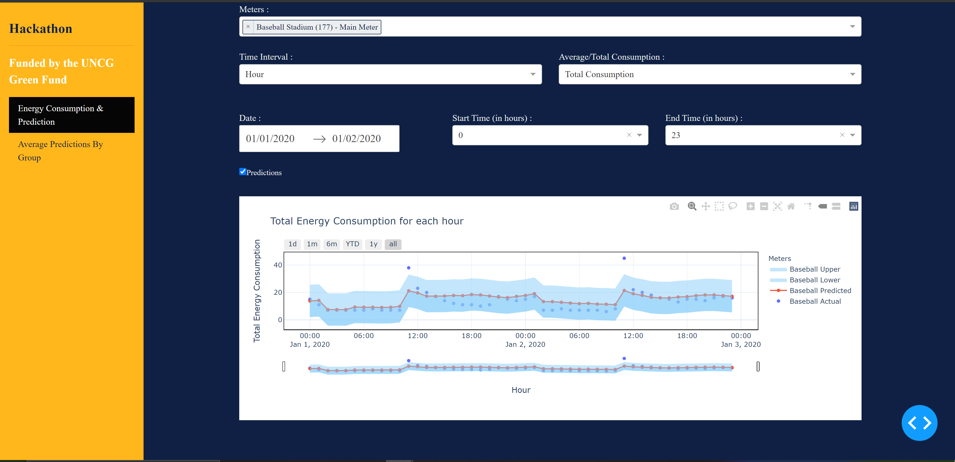

When the user clicks Average Predictions By Group button a new page opens as below.

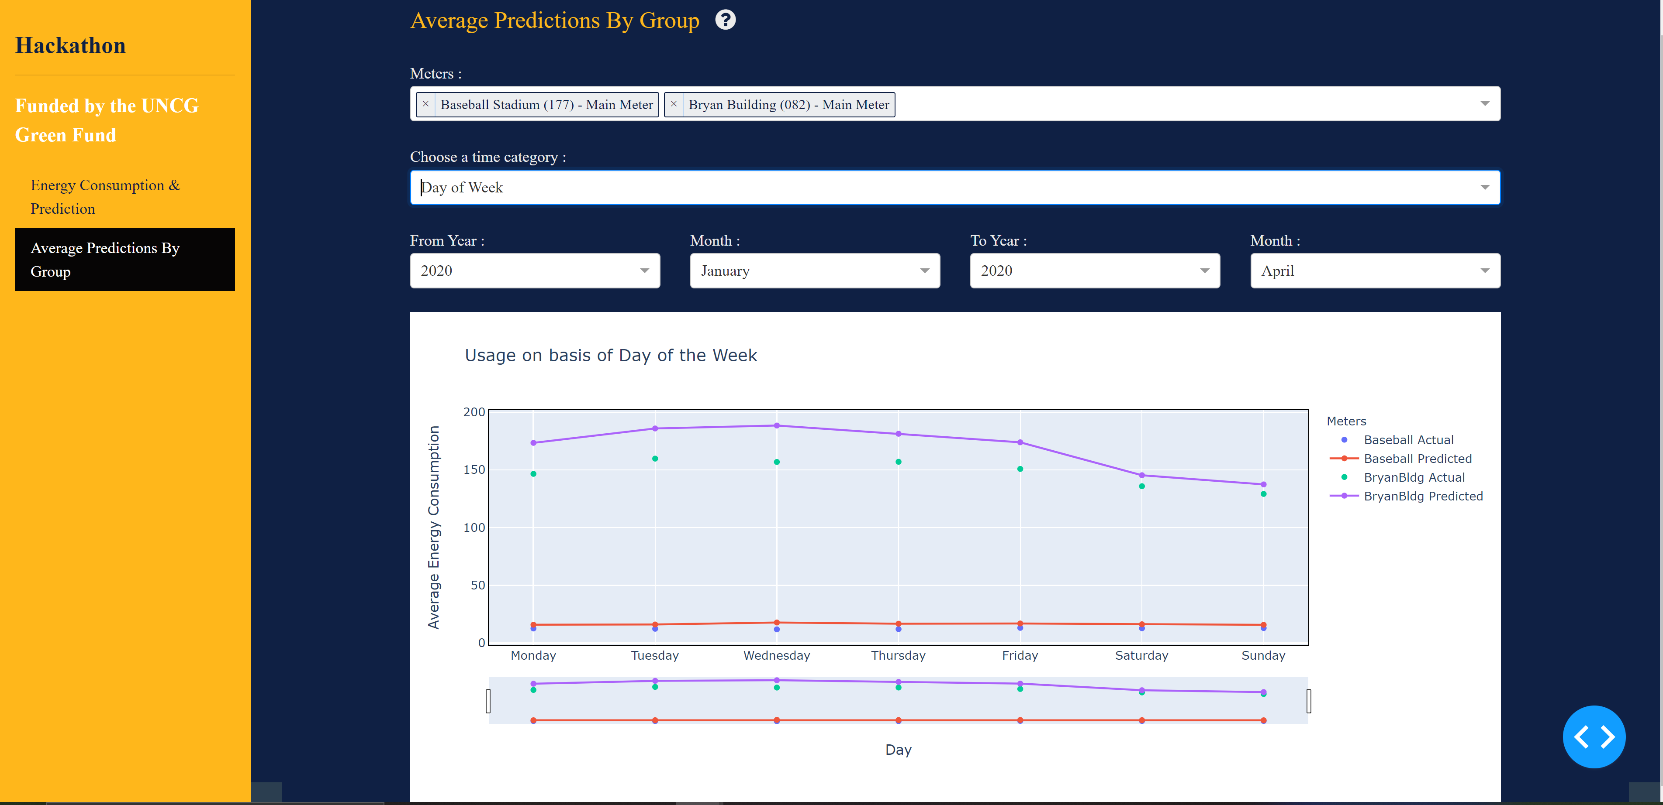

**3.1 Energy Consumption & Prediction :**

Meters:

User can select one or multiple meters at a time using this dropdown to visualize the graph.

Time Interval :

There are 5 options for the user to select under Time Interval dropdown,

1. Year
2. Month
3. Week
4. Day
5. Hour

Users can select one at a time. For instance, if the user wants to know the week’s energy consumption, he can select week in Time interval. If the user wants to know about an hour’s energy consumption, he can choose hour in Time Interval.

1. **Hour**: Please select to and from dates and to and from hours.

(**Note:** Select dates which are less than 6 months to check the hourly consumption otherwise, it may take a longer time to load)  
**2. Week:** Once the user clicks on week user will get year and week dropdown and he can select both the options to see the consumption graph for the weeks of the year chosen.  
**3. Month:** Once user selects the dates from the date picker, the user will get all the months consumption for that specific period of time.  
**4. Year:** Once user selects the dates from the date picker, the user will get the years consumption for the selected period of time.  
**5. Day:** Once the user selects the to and from dates from the date picker user will get the daily consumption of all the dates between the selected dates.

Average/Total Consumption:

There are 2 options for user in Average/Total Consumption button.

1. Total Consumption
2. Average Consumption

For Instance, user can select Total Consumption if he wants to know about the total consumption of the meters in a particular time interval. Similarly, if the user selects Average Consumption the graph will be displayed for the average energy consumption for the meters.

Date :

In Date picker user can select a date from the calendar that appears after clicking it. There are both From date and To date, user can select particular dates.

Start Time(in hours):

This is the dropdown where users can select a particular hour as there are 24 hours in a day users have 24 options to choose.

End Time (in hours):

This is the dropdown where the user can select a particular hour.

Predictions :

User can select ‘Predictions’ check box. If he checks it, he can see both the actual and predicted values in the graph for the conditions that he had selected.

For hourly Consumption prediction level also will be displayed on the graph.

**3.2 Average Predictions By Group:**

Meters :

In Meters dropdown, there are 81 meters included so users can select one or multiple meters to visualize the graph. If the user clicks x on the selected meter, he can remove that meter from the selected meters.

Choose a time category:

In Choose a time Category dropdown user has four options as below

1. Hour of Day
2. Day of Week
3. Week of Year
4. Month of Year

And there is also From and To for Year and Month.

A graph for the 2020 year average predictions data will be displayed for the user's particular selected category and timeframe.

For instance, if the user chooses hour of day, the Bryan Building meter, and July 2020-Sep 2020. The graph would plot the average actual and average predicted consumption in Bryan building for the year 2020 from July-Sep months by hour of the day. There would be one observation per hour in a day, so 24 in total.

A range slider and selector are there for every graph where the user can drag and move along the x-axis to see the detailed data.

1d --- data for 1 day

1m -- data for 1 month

6m – data for 6 months

YTD -- Year to Date data

1y -- 1 year data

All – all data

**3.3 Help (?) :**

If user clicks on the ‘?’ symbol, instructions will be displayed to guide the process.

**4. Screenshots to show the functionality of App:**

* 1. The below screenshot shows the average energy consumption for a year for Baseball Stadium meter.

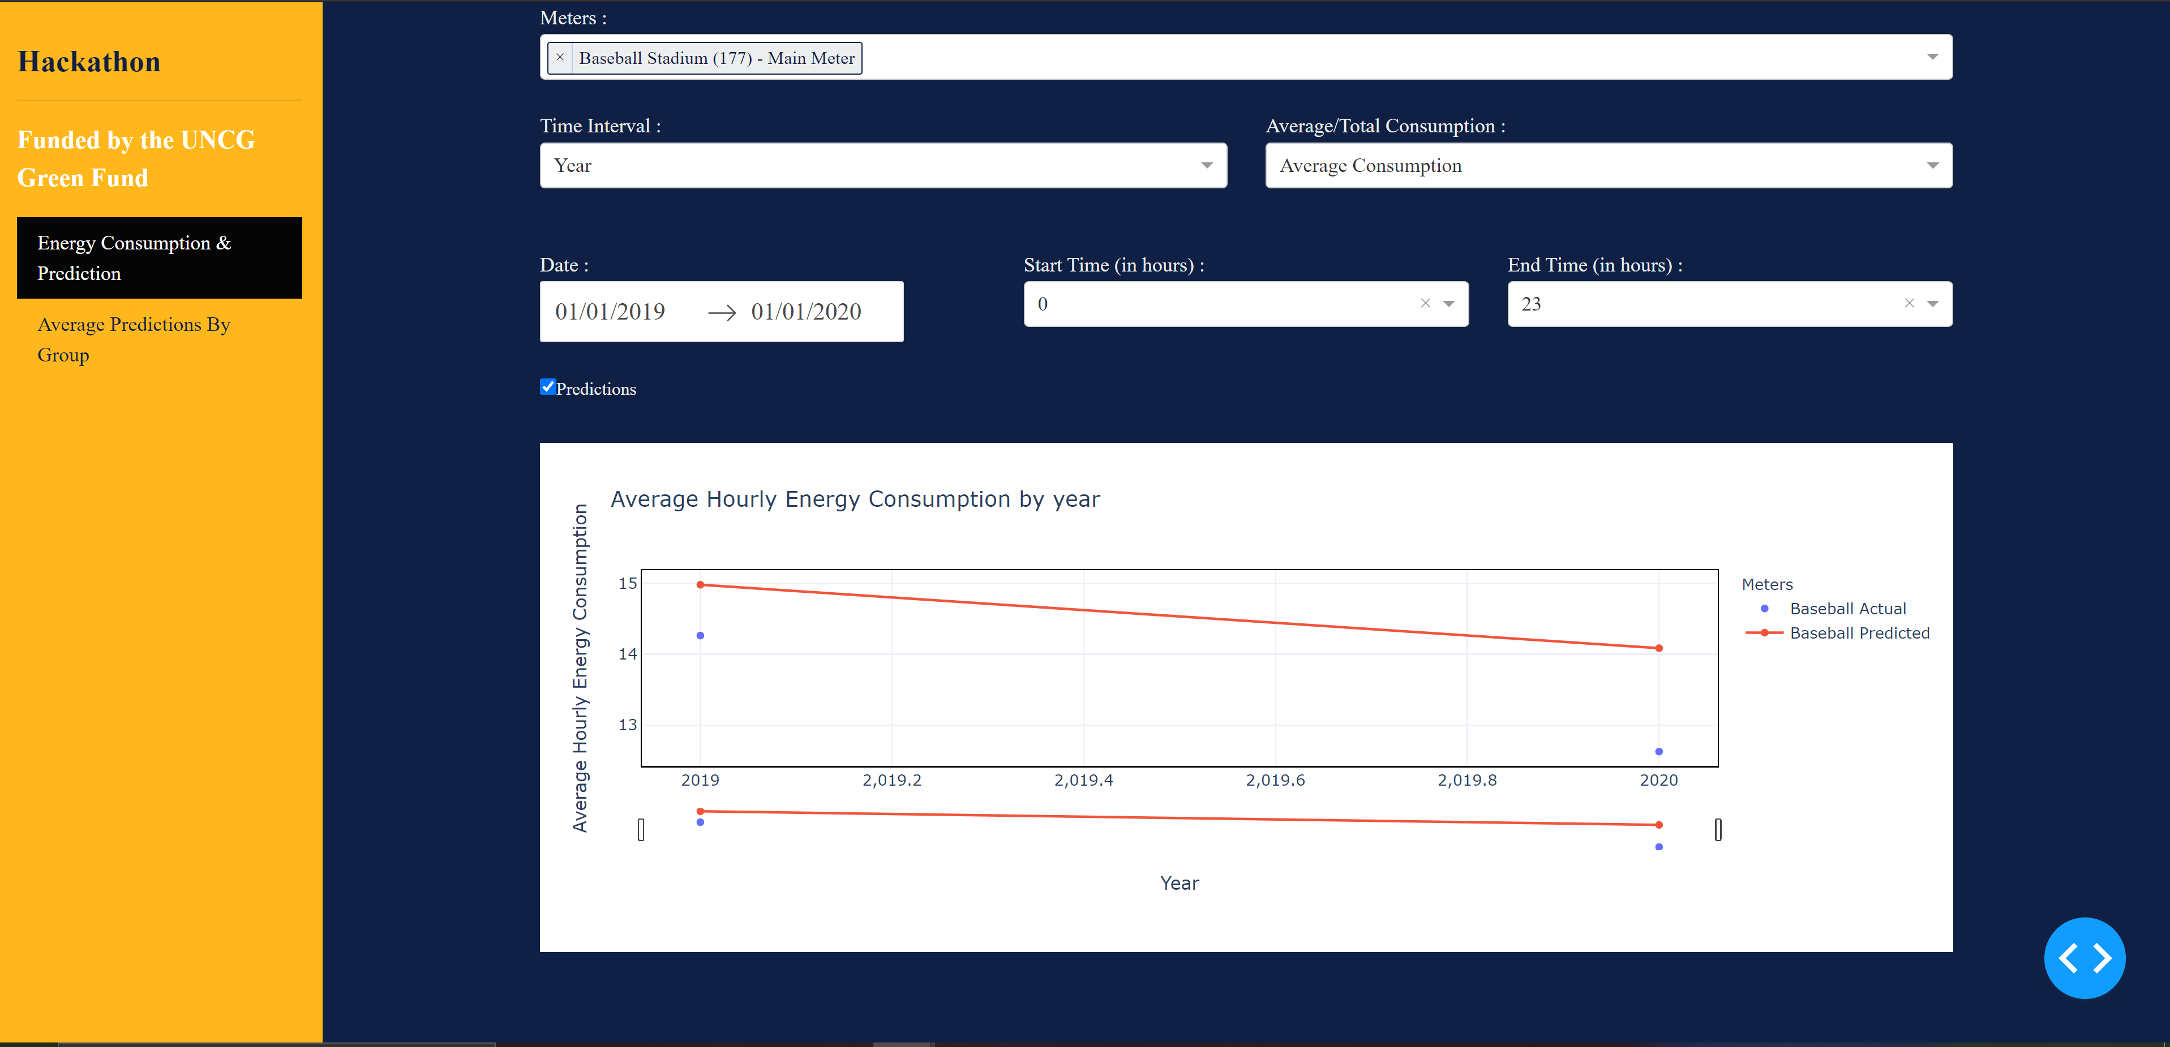

4.2 The below screenshot shows the Total energy consumption for a year for Baseball Stadium meter.

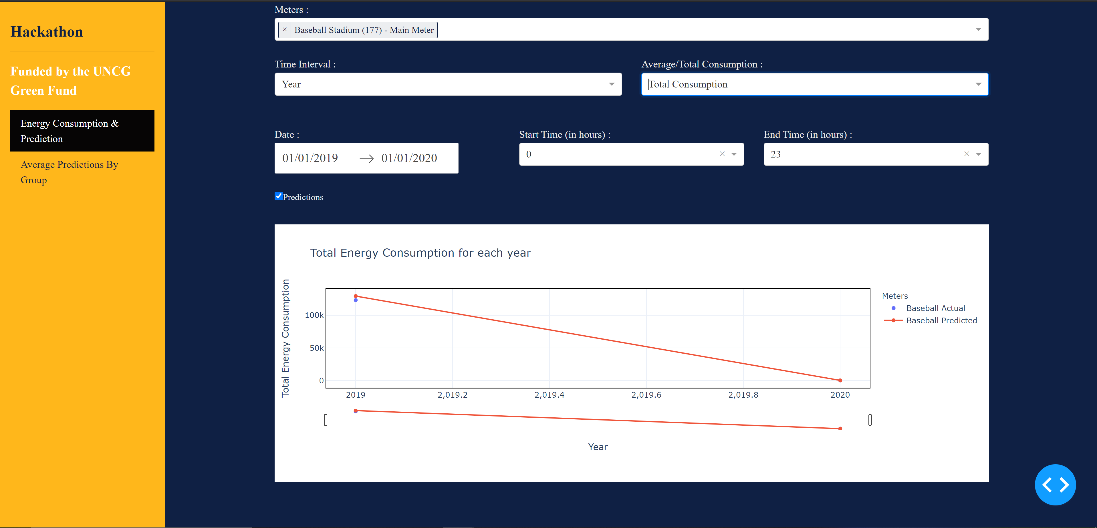

4.3The below screenshot shows the average energy consumption for each month

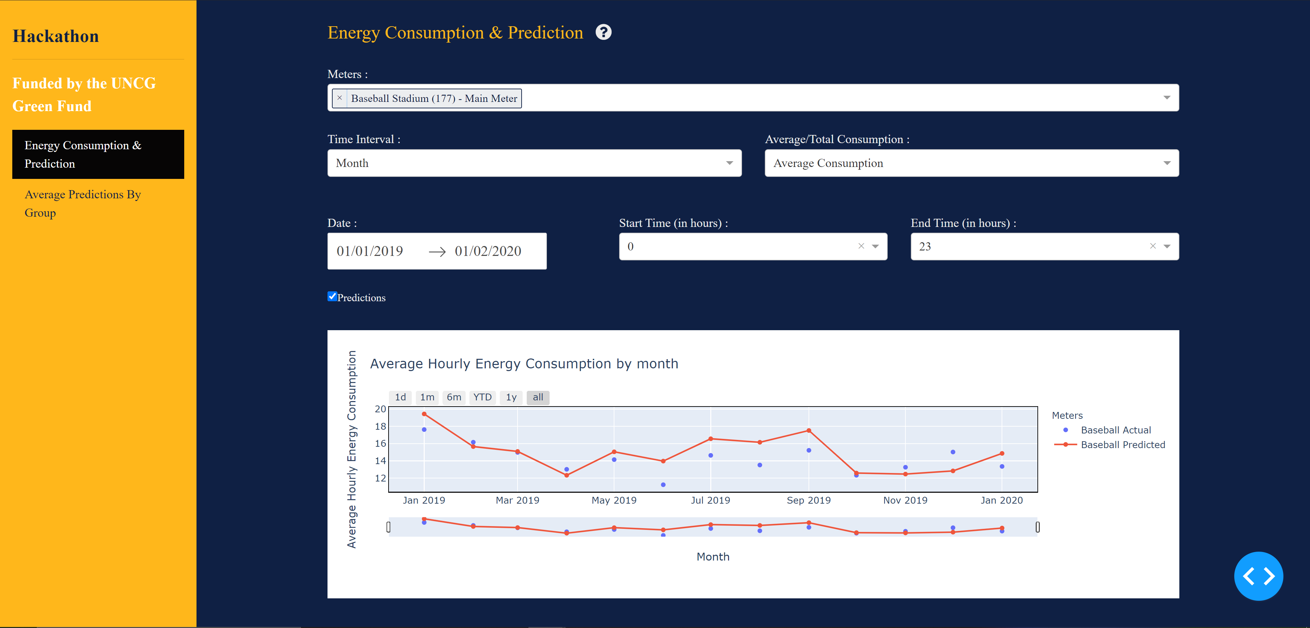

* 1. The below screenshot shows the total energy consumption for each month

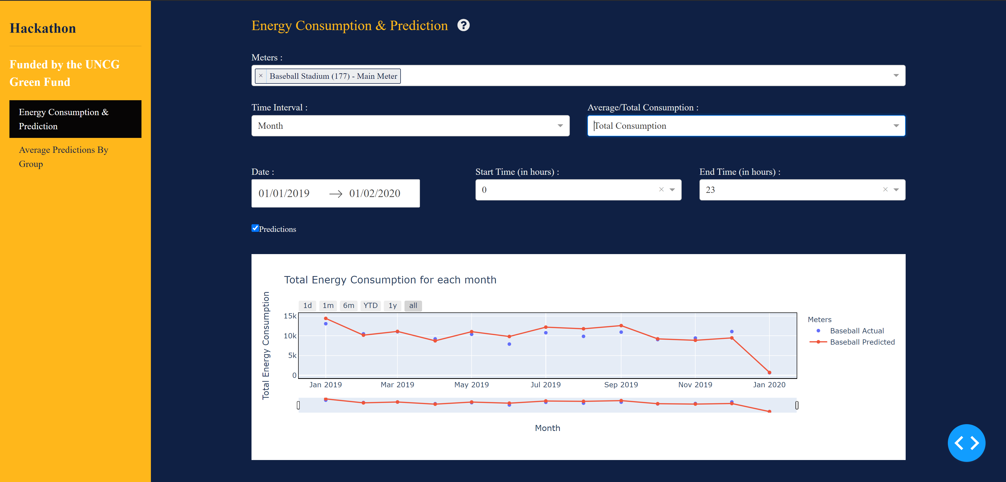

4.5 The below screenshot shows the Average hourly consumption by week for 2018 and 2019 years and for 30 and 35 weeks.

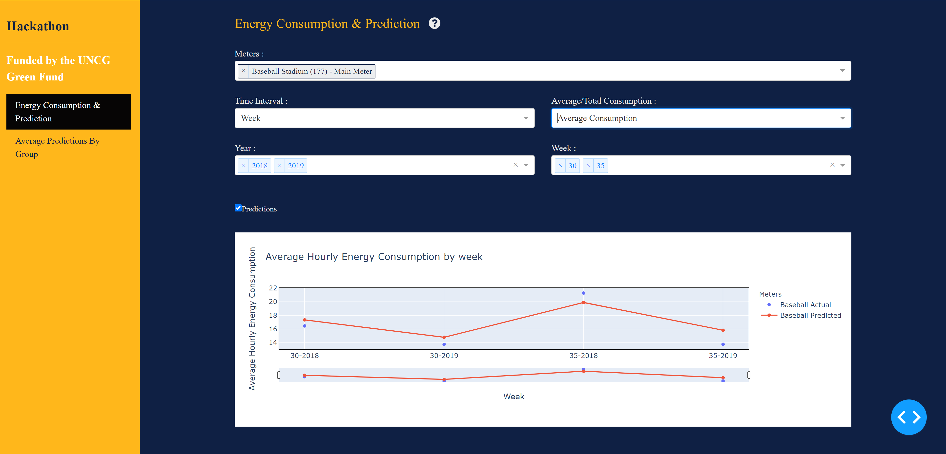

* 1. The below screenshot shows the Total hourly consumption by week for 2018 and 2019 years and for 30 and 35 weeks.

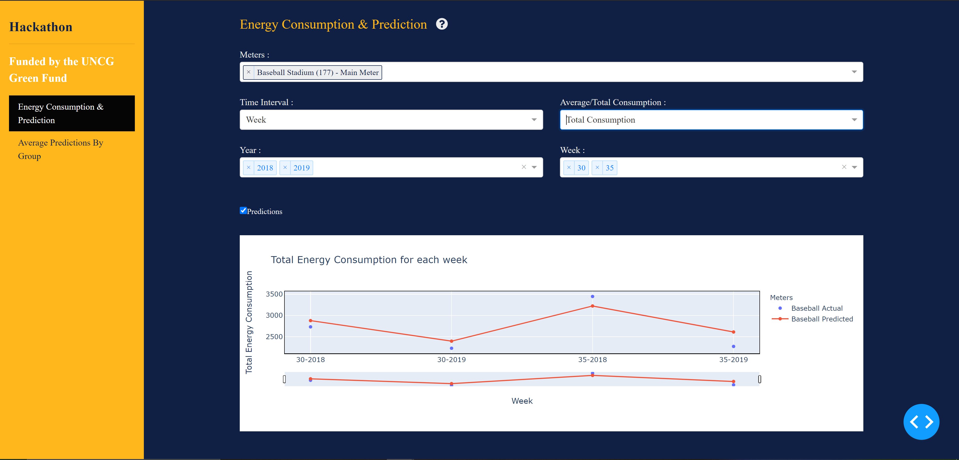

* 1. The below graph shows the average hourly energy consumption by day for Jan 1st 2020 to Jan 2nd 2020 data.

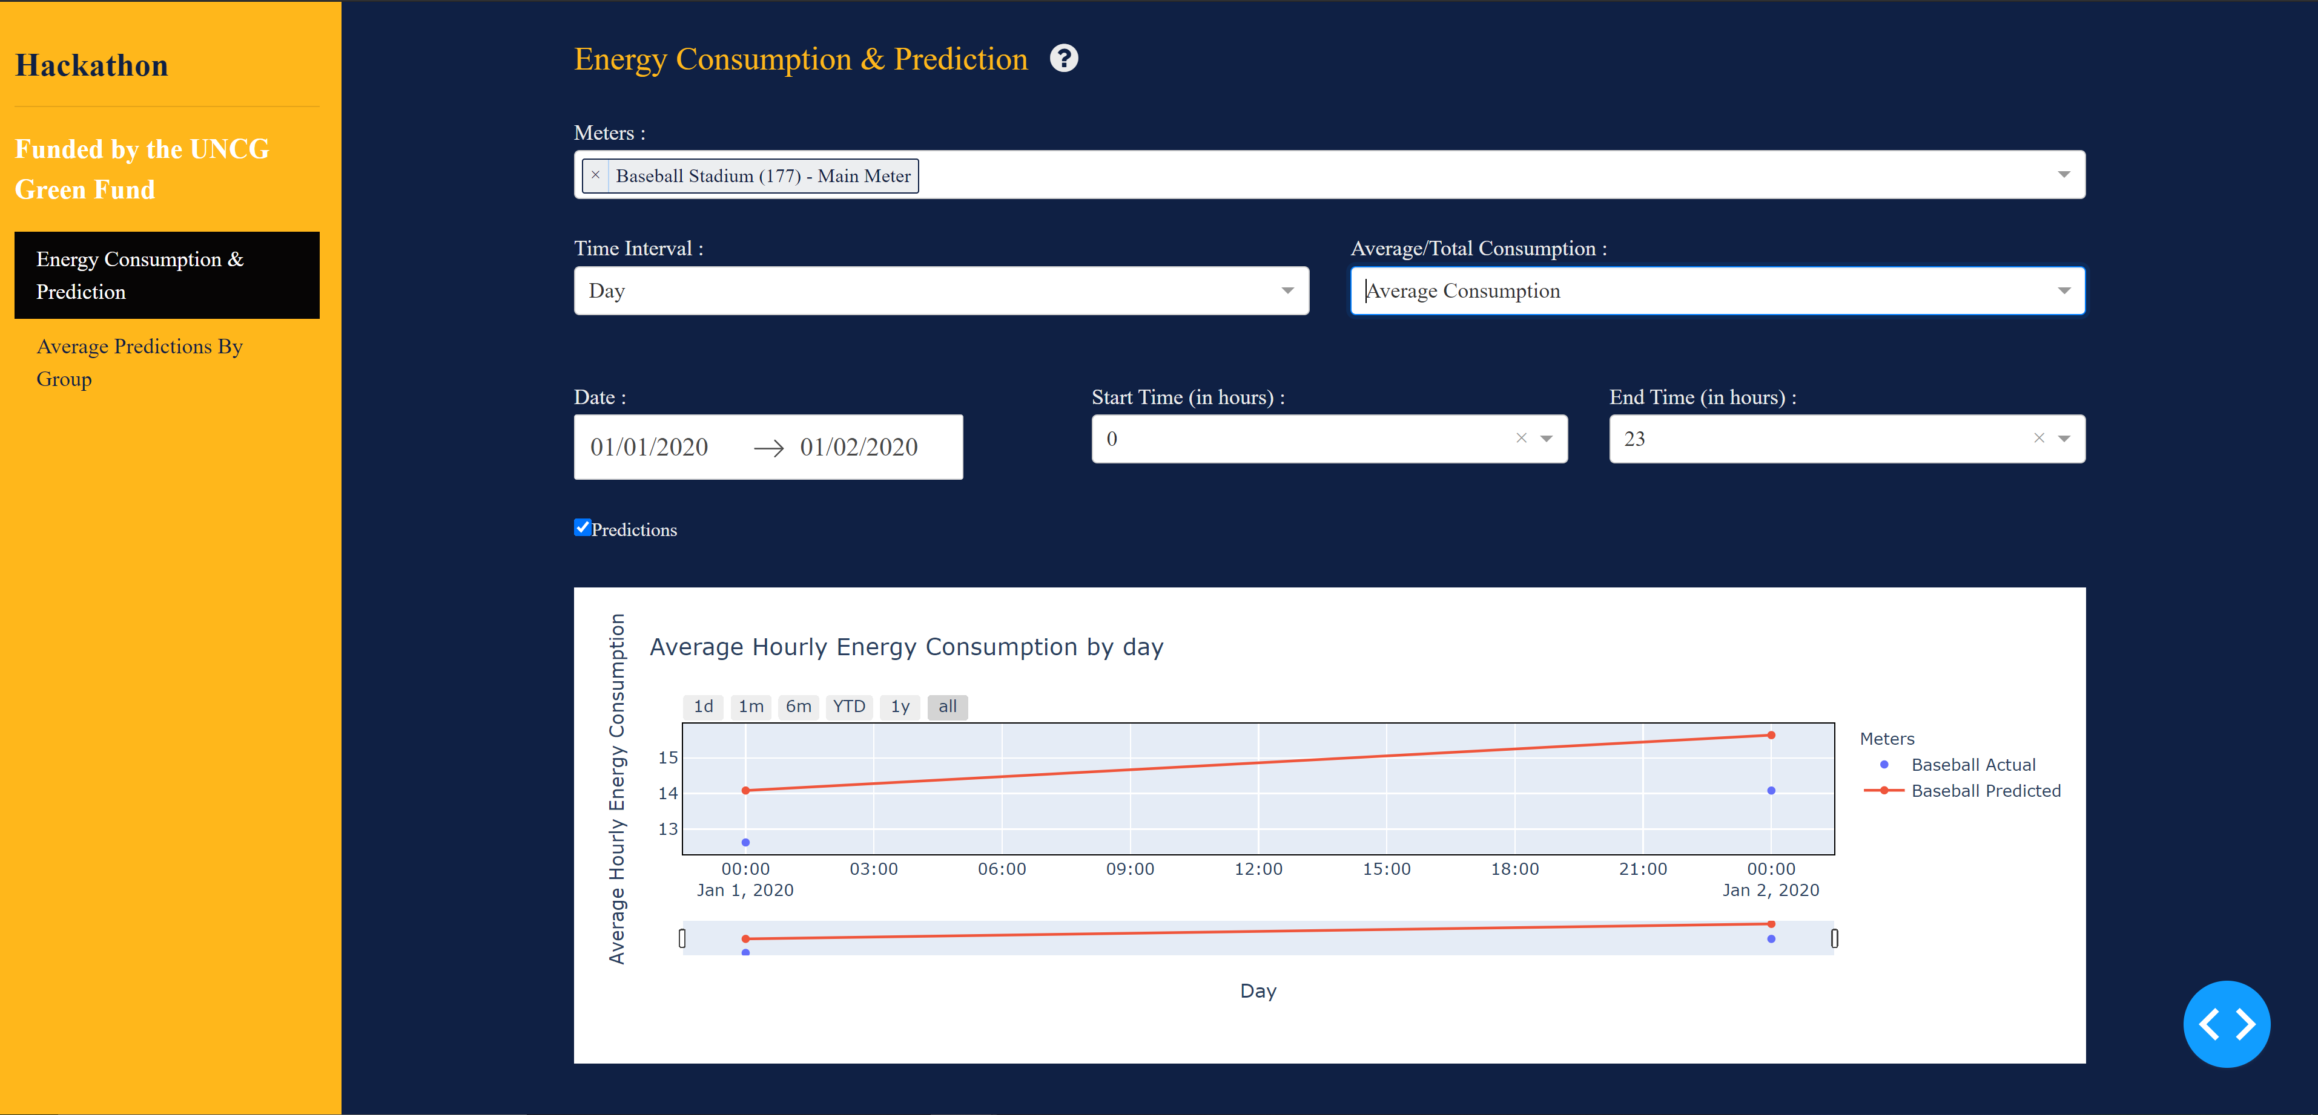

* 1. The below graph shows the Total hourly energy consumption by day for Jan 1st 2020 to Jan 2nd 2020 data.

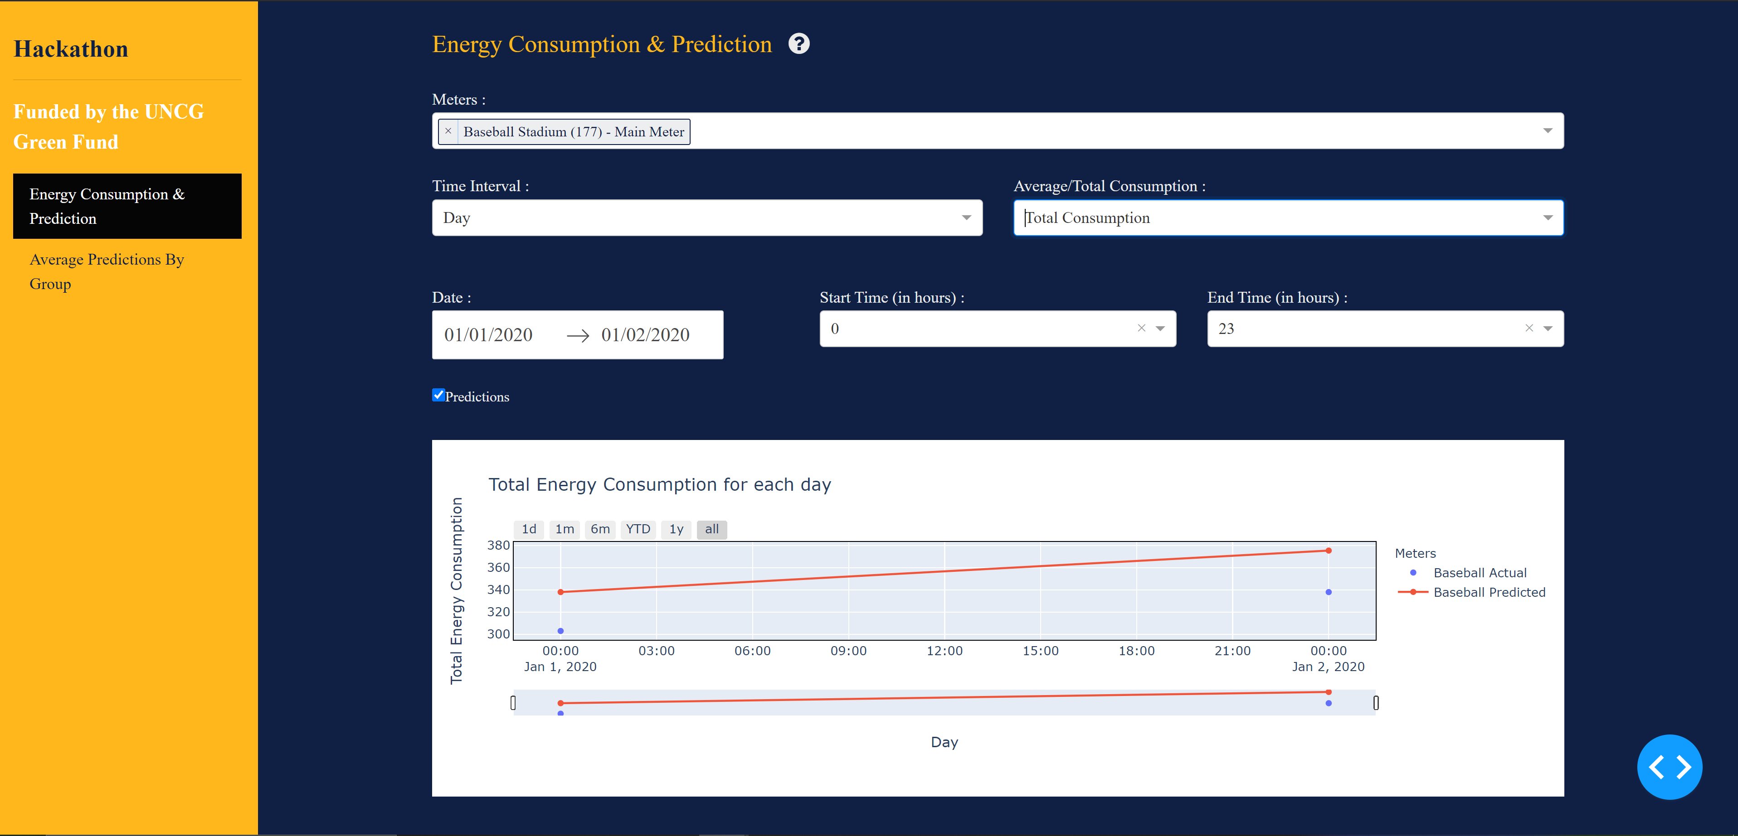

* 1. The below graph shows the Total energy consumption for each hour from Jan 1st 2020 to Jan 2nd 2020

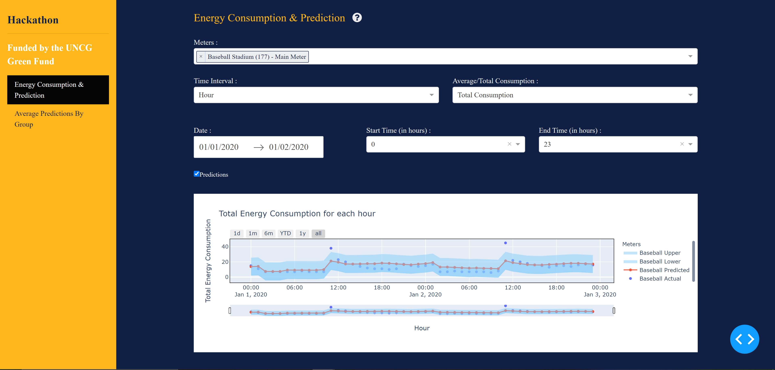

* 1. The below graph shows the Average energy consumption for each hour from Jan 1st 2020 to Jan 2nd 2020

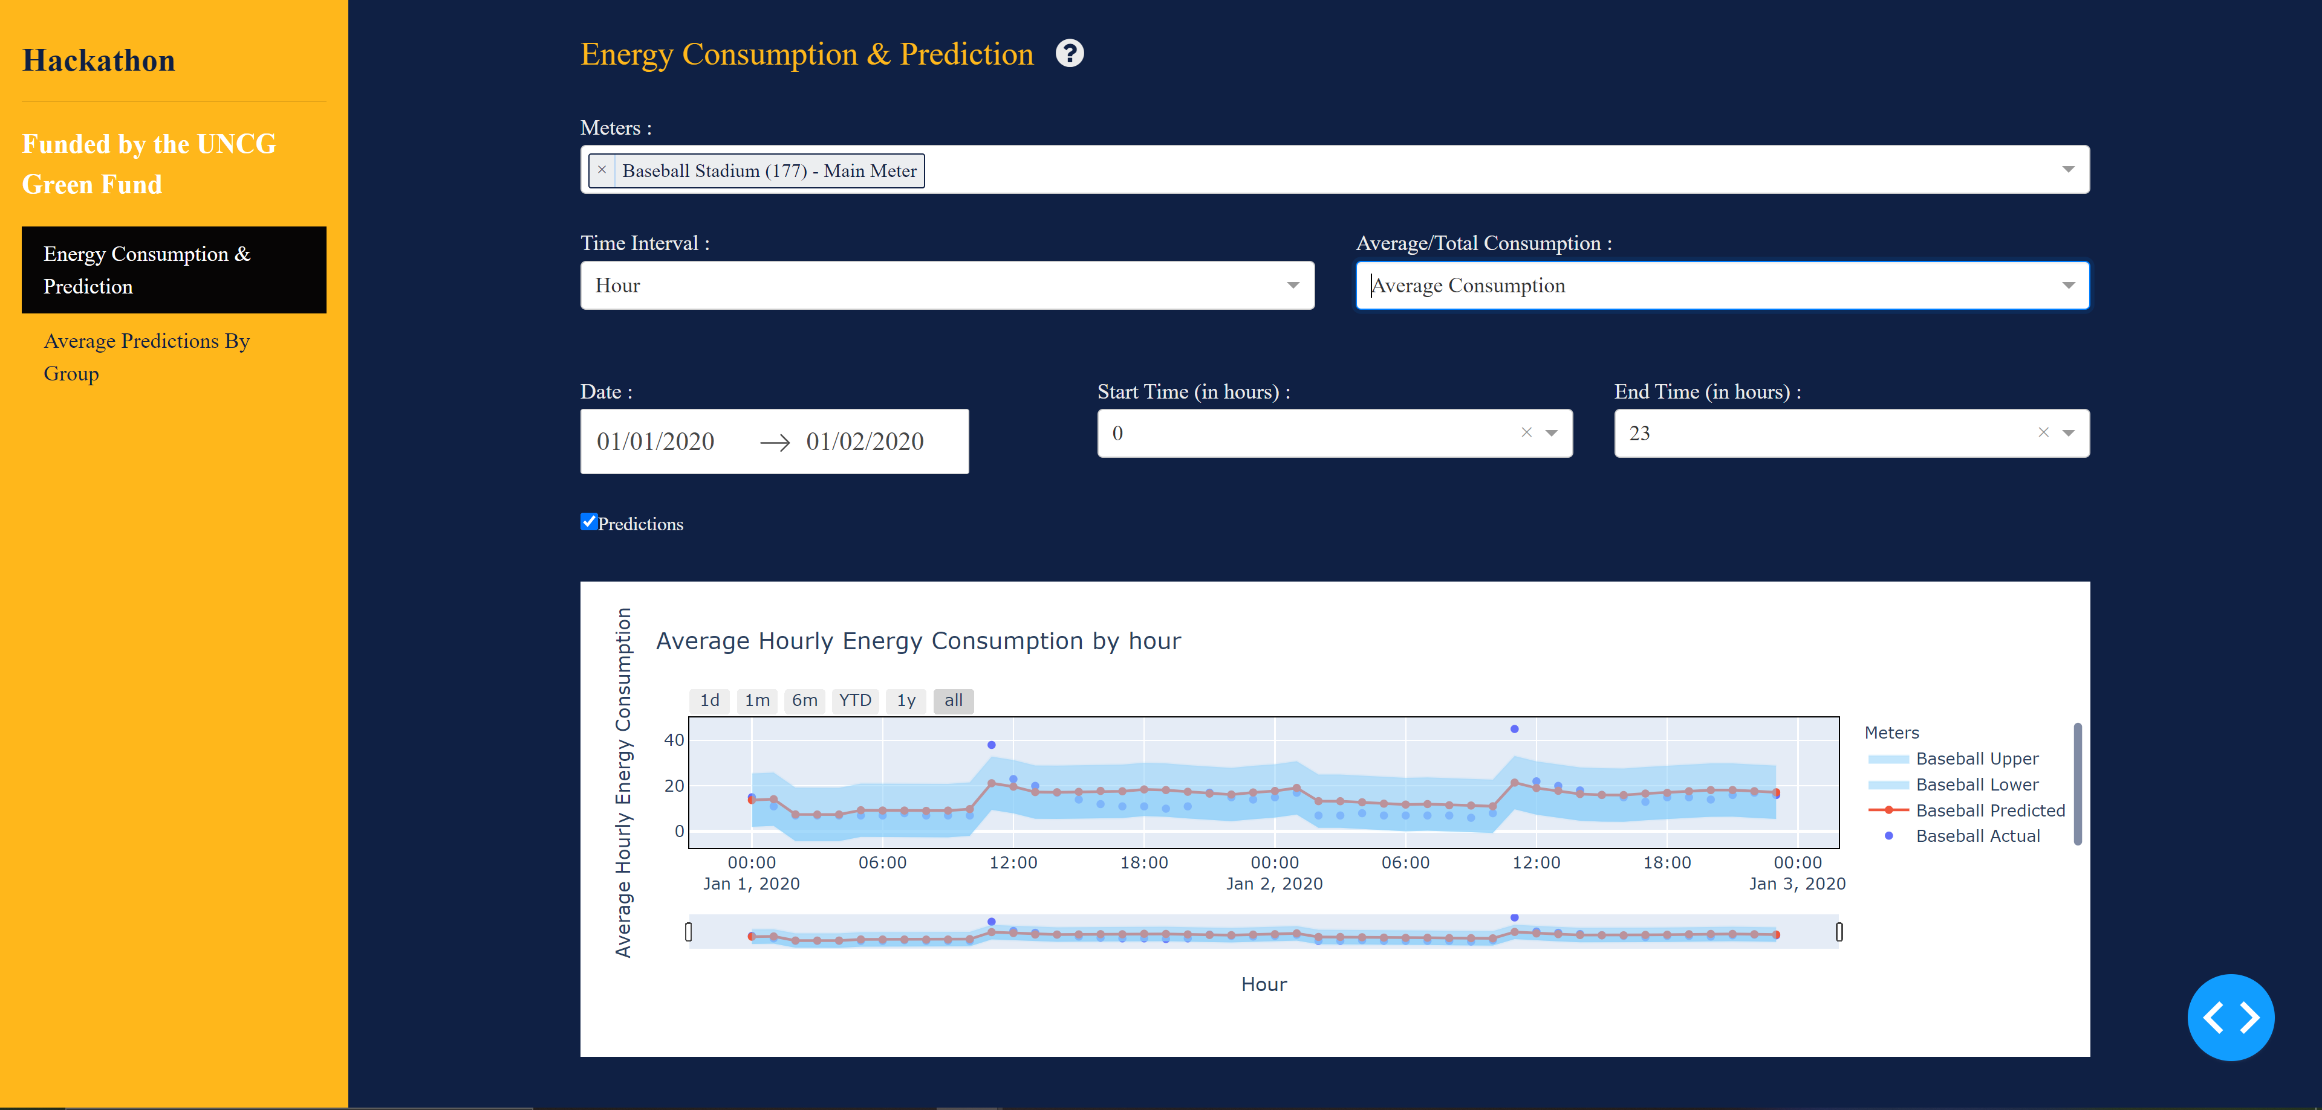

* 1. The below screenshot shows the Average prediction by group of Baseball Stadium(177)- Main Meter’s usage on basis of hour of the day.

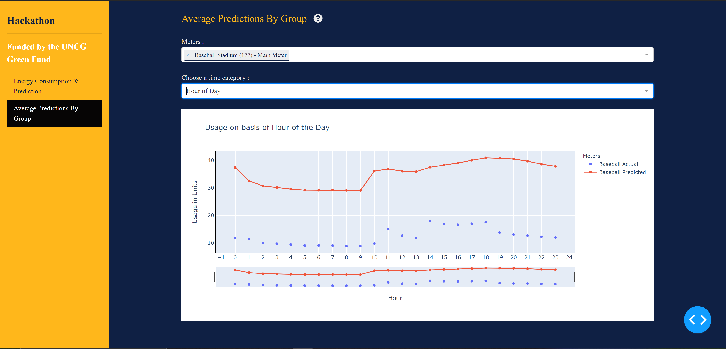

* 1. The below screenshot shows the Average prediction by group of Baseball Stadium(177)- Main Meter’s and Bryan Building(082)-Main Meter usage on basis of hour of the day.

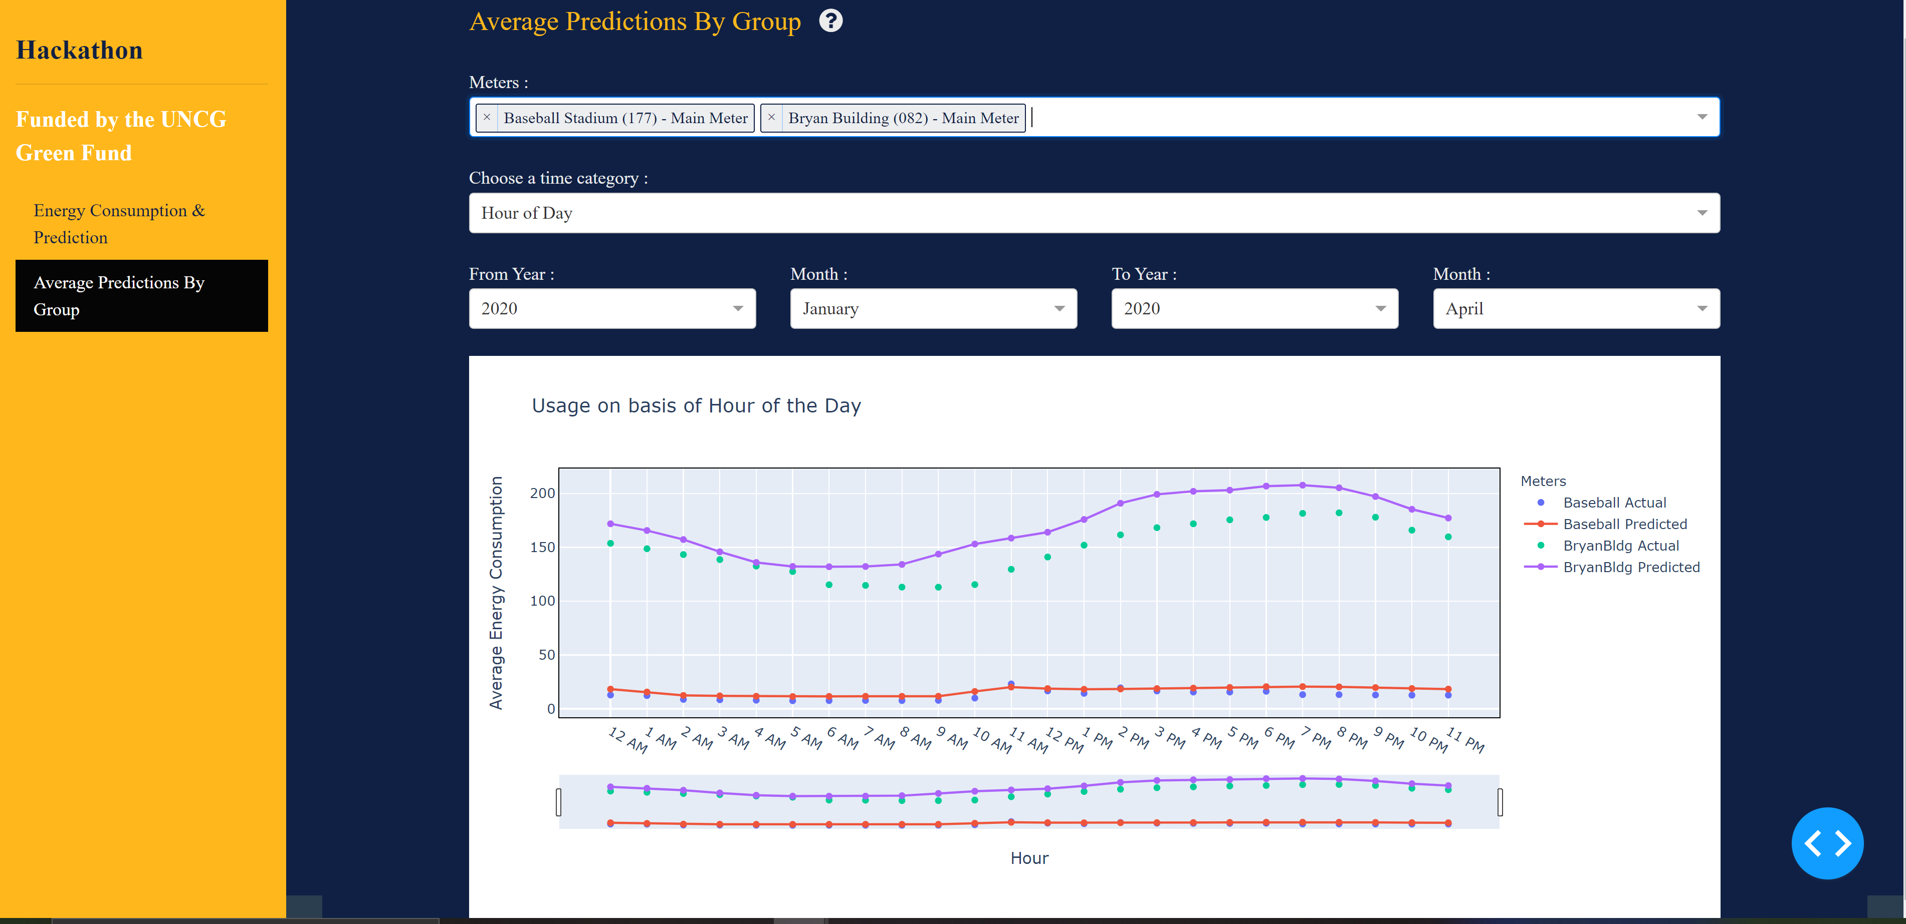

* 1. The below screenshot shows the Average prediction by group of Baseball Stadium(177)- Main Meter’s and Bryan Building(082)-Main Meter usage on basis of day of the week.



4.14 The below screenshot shows the Average prediction by group of Baseball Stadium(177)- Main Meter’s and Bryan Building(082)-Main Meter usage on basis of week of Year.

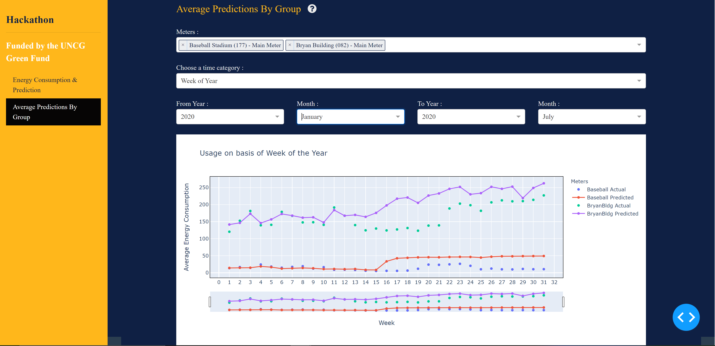

* 1. The below screenshot shows the Average prediction by group of Baseball Stadium(177)- Main Meter’s and Bryan Building(082)-Main Meter usage on basis of Month of the Year.

